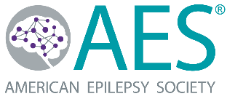

Memorandum of Understanding

2023 Epilepsy and Clinical Neurophysiology Match

for the 2024-2025 Academic Year

Please complete (insert institution name, city and state) and sign this MOU by January 31, 2022 and return to the attention of Eileen Murray at emurray@aesnet.org.

This Memorandum of Understanding (MOU) takes effect on date of last signature between the American Epilepsy Society (AES), a nonprofit corporation with its principal place of business at 135 S LaSalle Street, Suite 2850, Chicago, IL 60603, and [insert Name of Institution], an institution located at [insert City, State]

- Purpose. AES has evaluated how to improve the current interview and offer process for residents who apply to epilepsy and/or clinical neurophysiology fellowship programs. AES, in collaboration with the American Clinical Neurophysiology Society (ACNS), formed an Epilepsy and Clinical Neurophysiology Fellowship Work Group to simplify and streamline that process. That initiative has led to AES establishing an Epilepsy and Clinical Neurophysiology Fellowship Match Program. The Program will allow applicants and fellowship programs an opportunity to consider options before deciding on specific candidates. Additionally, the Program will set a uniform date and timeline for applicants and permit residents to apply one year before entering a fellowship so they may make informed decisions about their profession. AES desires U.S.-based fellowship programs to participate in the Program. Participating programs must be accredited or affiliated with an ACGME program; sign a sponsorship agreement and agree with the National Resident Matching Program’s timeframe. This Memorandum of Understanding establishes the parties’ responsibilities regarding this educational initiative.

- No Offers Commitment. AES requests that participating programs not make any offers to applicants for the 2024 fellowship year outside the match process. Participating programs may interview candidates starting on Nov. 28, 2022, as long as an offer is not extended.

- Term and Termination. Programs must enter into this MOU by January 31, 2022. At any time, the parties may extend and/or modify the MOU beyond the initial term. Alternatively, either party may terminate the MOU on thirty (30) days’ written notice provided by any reasonable business means.

- Entirety. This MOU constitutes the entire understanding and agreement between the parties. Any additions or amendments to this MOU must be in writing and signed by both parties.

American Epilepsy Society (insert Name of Institution)
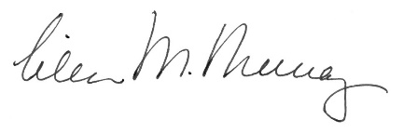 (insert signature)

Eileen M. Murray, MM, CAE Name:
Executive Director Title:
Date: December 30, 2021 Date:

